**Lab 9**

**Name:** Etcherla Sai Manoj **Mis. No:** 112015044 **Branch:** CSE

**Question1:**

**Code:**

#include<iostream>

#include<fstream>

using namespace std;

int main(){

fstream my_file;

//writing a file

my_file.open("first.txt", ios::out);

if(!my_file){

cout << "File not found\n";

}

else{

cout << "File found\n";

cout << "Writing in file...\n";

my_file << "This file is created by Sai Manoj Etcherla";

cout << "Writing Completed\n";

my_file.close();

}

//reading a file and printing its contents

cout << "\nReading and Printing content of file...\n\n";

my_file.open("first.txt", ios::in);

if(!my_file){

cout << "No such file is found\n";

}

else{

string s;

while(getline(my_file, s)){

cout << s << endl;

if(my_file.eof()) break;

}

}

my_file.close();

return 0;

}

**Input & Output:**

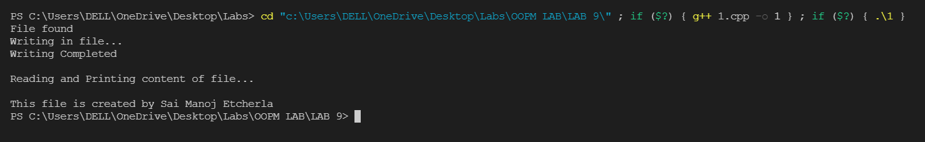

**Question2:**

**Code:**

#include<iostream>

#include<fstream>

using namespace std;

int main(){

string name, designation, dob, salary;

cout << "Enter employee name : ";

cin >> name;

cout << "Enter employee designation : ";

cin >> designation;

cout << "Enter employee date of birth (dd/mm/yy) : ";

cin >> dob;

cout << "Enter employee salary(per month) : ";

cin >> salary;

fstream my_file;

//writing a file

my_file.open("Emp.txt", ios::out);

if(!my_file){

cout << "File not found\n";

}

else{

cout << "\nFile found\n";

cout << "Wrinting employee details in file...\n";

my_file << "Employee name : " << name << "\n";

my_file << "Employee designation : " << designation << "\n";

my_file << "Employee date of birth(dd/mm/yy) : " << dob << "\n";

my_file << "Employee salary : " << salary;

cout << "Writing completed\n";

my_file.close();

}

//reading a file and printing its contents

cout << "\nReading and Printing content of file...\n";

cout << "------------------------------------------\n";

my_file.open("Emp.txt", ios::in);

if(!my_file){

cout << "No such file is found\n";

}

else{

string s;

while(getline(my_file, s)){

cout << s << endl;

if(my_file.eof()) break;

}

}

cout << "------------------------------------------\n";

my_file.close();

return 0;

}

**Input & Output:**

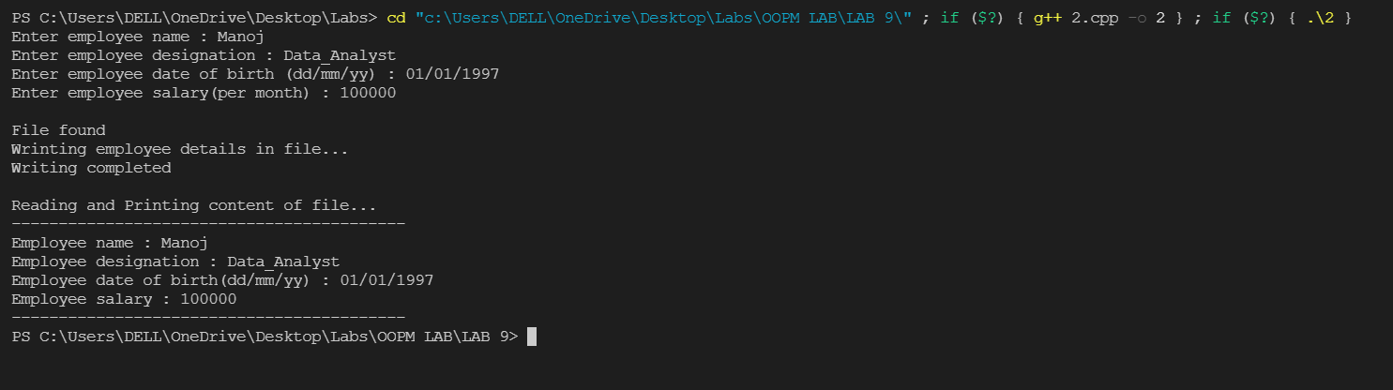

**Question3:**

**Code:**

#include <iostream>

using namespace std;

int main() {

string str;

string temp = "";

cout << "------------------------------------------\n";

cout << "Enter a string: ";

getline(cin, str);

for (int i = 0; i < str.size(); ++i) {

if ((str[i] >= 'a' && str[i] <= 'z') || (str[i] >= 'A' && str[i] <= 'Z') || (str[i] >= '0' && str[i] <= '9')) {

temp = temp + str[i];

}

}

str = temp;

for(int i = 0; i < str.size(); ++i){

if(isupper(str[i])){

str[i] = tolower(str[i]);

}

}

cout << "\nFinal String : " << str << endl;

int length = str.length(), flag = 0;

for(int i = 0; i < str.size(); ++i){

if(str[i] != str[length-i-1]){

flag = 1;

break;

}

}

if(flag){

cout << "\nThe string is not a PALINDROME\n";

}

else{

cout << "\nThe string is a PALINDROME\n";

}

cout << "------------------------------------------\n";

return 0;

}

**Input & Output:**

